Instructions for preparing a paper to be included in the conference proceedings

Dipl.-Ing. Dr.techn. Petra MAYER  
Dipl.-Ing. Moritz ČZERNY

Institute of Geotechnics, Technical University of Xylo

Dipl.-Ing. Max WAGNER

Ingenieurbüro Müller + Partner, Vienna

ABSTRACT

This document provides information and instructions for preparing a paper to be included in the Proceedings of the Austrian Geotechnical Conference. Please use this template to create your paper, which **should not exceed 12 pages**. In order to ensure uniform style throughout the volume, the paper must be prepared strictly according to these instructions.

Beneath title, authors and affiliations an abstract should give a quick overview of your essay, its key points and its organization if necessary. Please note that the headings „Abstract“ and „Literature“ are not to be numbered.

# INTRODUCTION

## Paper size and layout

Please use this template in paper size **DIN ISO B5** (page height 25,0 cm, paper width 17,6 cm, see (Gl. 1)). Proceedings will be published in the same size without reduction.

|  |  |
| --- | --- |
| DIN B5: | (Gl. 1) |

### Page Setup: Margin settings for B5 size paper

* Top: 2,0 cm Bottom: 2,0 cm (0,787 inch)
* Left: 1,5 cm Right: 1,5 cm (0,590 inch)
* Inside margin: 0,8 cm Margin position: left

### Page layout / Header an Footer

* 🗹 Different First Page
* 🗹 Different Odd & Even Pages

## First page and and headers

Every papers first page is located at right page (odd) of the conference proceedings.

* Title of paper
* Academic title, name of authors (last name in BLOCK CAPITALS) and their affiliation
* Abstract
* Content of the paper, starting with heading 1

Starting from page 2 a header is located at the top of the page aligned to the outer margin. Type in Arial 8.5 points italic the **last names of the authors** separated by a comma, followed by “ / “ and the **paper title** at page 2 (left-justified at even pages) and page 3 (right-justified at odd pages). Please leave **footers blank, without page numbers**.

## Text body

Use Arial 9 point size and line spacing of 1.2, justified (text tag). Paragraphs are never indented.

**Papers should not exceed 12 pages.**

**Please note**: Use a **protected space** by "***strg*" + "s*hift*" + "*space***" to separate every dimension number from its unit.

## Citation

In the text, place the authors’ last names (without initials) and the date of publication in parentheses [Vamvatsikos 2011a, Vamvatsikos and Cornell 2002, Vamvatsikos et al. 2005].

These citations should refer to the literature at the end of the paper [Potts, Zdravković, 2001].

## Listing and numbering

A list should be arranged as shown below:

* Use the List tag for lists.
* This is the second topic of this list.

# FIGURES And TAbLES

## Position and caption

The most convenient place for figures is the top or bottom of the page. Use the Figure tag for figures and the Figure caption tag for the captions. See for example Fig. 1.

### Figures, diagrams and photographs

* Please ensure that the figures are of high quality **≥ 300 dpi**. Two Figures can be placed side by side.
* Number figures consecutively in the order in which reference is made to them in the text, making no distinction between diagrams and photographs.



Fig. 1: If figure caption contains more text than one line it should be left-justified, otherwise centred; this alignment also applies to tables.

* Figures should be centred, figure caption also centred if one-line, otherwise left-justified.

Type the caption above the table in Arial 9 point size (Table caption tag). Locate tables close to the first reference to them in the text and number them consecutively. Table text should have a minimum font size of 6 pt. Use the Table tag for tables. Refer to tables in the text (see Tab. 1).

Tab. 1: Typefont, typesize and spacing (caption centred if one-line)

|  |  |  |  |  |  |  |
| --- | --- | --- | --- | --- | --- | --- |
| type | font | size | style | line spacing | alignment | block capitals |
| title | Arial | 12 p | bold | 1,2 | centred |  |
| Author(s) & affiliation(s) | Arial | 8,5 p | normal | 1,2 | centred | last name |
| Headings | Arial | 8,5 p | italic | 1,2 | left / right |  |
| Abstract + Literature | Arial | 10 p | bold | 1,2 | left-justified | yes |
| 1. Heading | Arial | 10 p | bold | 1,2 | justified | yes |
| 2. Heading | Arial | 9 p | bold | 1,2 | justified |  |
| 3. Heading | Arial | 9 p | normal | 1,2 | justified |  |
| Text | Arial | 9 p | normal | 1,2 | justified |  |
| Figure caption | Arial | 9 p | normal | 1,0 | justified |  |
| Table cation | Arial | 9 p | normal | 1,0 | justified |  |
| Table text | Arial | 6-8 p | normal | 1,0 | left / centred |  |
| Equation text | Arial | 9 p | normal | 1,0 | centred |  |
| Equation variable | Arial | 9 p | italic | 1,0 | centred |  |
| Equation symbols | Symbol | 9 p | italic | 1,0 | centred |  |
| Equation numbers | Arial | 9 p | normal | 1,0 | centred |  |
| References, citations | Arial | 9 p | normal | 1,0 | justified |  |

# Copyright NOTICE

The form **copyright notice** regarding your paper and presentation is available in the download area of the conference website (personal login). Please be so kind and submit the signed form via upload together with your paper.

**Please note**: All references are to be cited correctly, particularly maps, drawings, pictures or other internet data.

# SUBMISSION OF PAPERS

## Upload via conference website

The submission of your **paper (WORD und PDF)** and the **signed copyright notice** will be done as follows:

* Please register at the conference website [www.voebu.at/oegt](http://www.voebu.at/oegt) (done)
* Login to the authors platform (personal login)
* In the area “Upload” follow the link **„Link zum ID-Ordner der** **TU-ownCloud**“ (see Fig. 2)
* For submission of your **WORD- und PDF-Files** please follow your link to the server of TU Wien.
* In the TU-ownCloud please click on the **symbol +** and **↑ “Upload” (German: “Hochladen”),** (see Fig. 3).
* Please choose all files of your paper (**WORD und PDF**) and the signed copyright notice in the explorer window.
* When successful the uploaded files are displayed (Fig. 4).

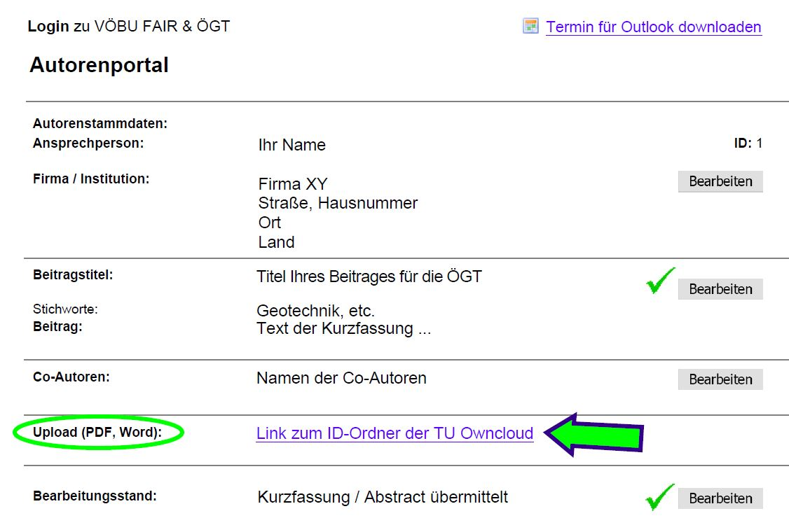

Fig. 2: Start your paper upload by following the link to TU Owncloud.

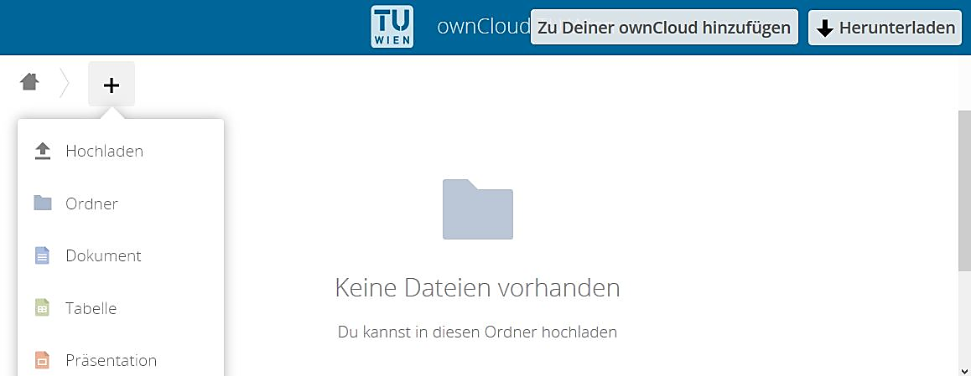

Fig. 3: Upload (by “Hochladen”) to the TU Wien ownCoud

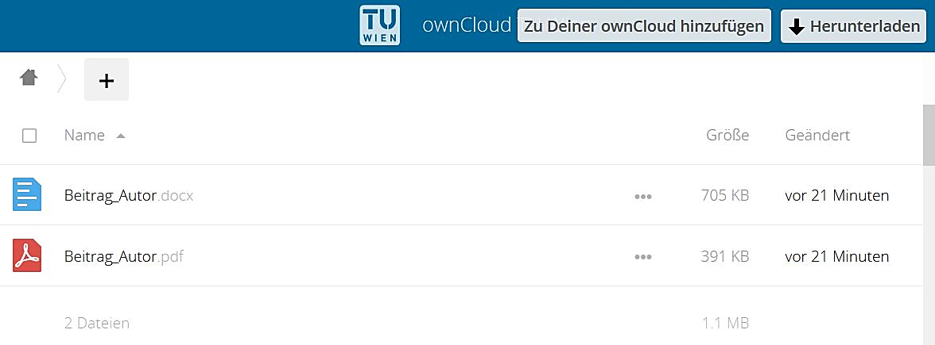

Fig. 4: View after the file upload

For any questions regarding the paper submission we are happy to help you, please contact the conference committee via

* Email: [oegt@tuwien.ac.at](mailto:oegt@tuwien.ac.at)
* Phone: +43 (0)1 58801 22 111

# CONCLUSIONS

Conclusions should state concisely the most important propositions of the paper.

We would like to express our gratitude for your willingness to create a paper for the **Austrian Geotechnical Conference.**

At the end of the paper, please list all references in alphabetical order underneath the heading REFERENCES as follows:

REFERENCES

Last name, First name initials (year). Title of article. *Journal title* **Journal volume**: pages.

Last name, First name initials (year). Title of article. In: Editor Last name, First name initials (eds), *Proceedings title*; Conference date, location, country. Paper No., number of pages. Publisher.

STANDARD (year). *Standard title*.

Last name, First name initials (year). *Book title*. Publisher.

Examples:

Adam, D. (2009): Energy from earth-coupled structures, foundations, tunnels and sewers. *Geotechnique* **3**: 229-236.

Müller et al. (2011): Technische Mechanik für Ingenieure. Springer-Verlag, Wien, New York.

Krawinkler, H., Zareian, F., Lignos, D.G. and Ibarra, L.F. (2009). Prediction of collapse of structures under earthquake excitations. In: Papadrakakis, M., Lagaros, N.D. and Fragiadakis M. (eds), *Proc. 2nd International Conference on Computational Methods in Structural Dynamics and Earthquake Engineering* (COMPDYN 2009); June 22-24, 2009, Rhodes, Greece. CD-ROM paper, Paper No. CD449, 19 pp.